September Haden SD Intensive 2020
Thursday afternoon meditation
Guided Meditation Script

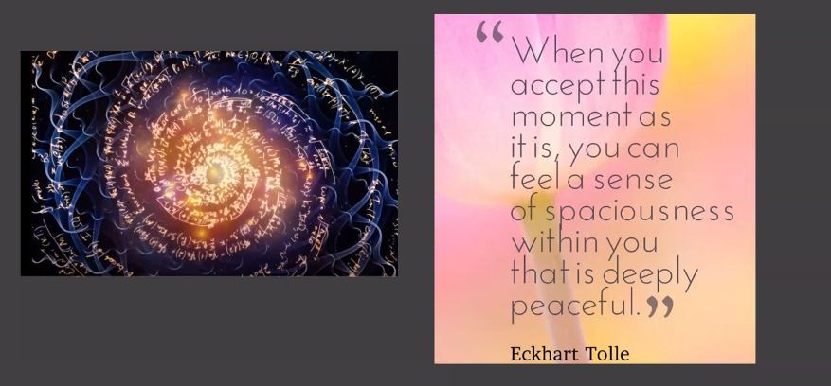

SUGGESTIONS FOR AN OPEN FOCUS MEDITATION ON SPACIOUSNESS
Adapted from Open Focus Brain: Harnessing the Power of Attention to Heal Mind and Body by Les Fehmi, PhD and Jim Robbins
We invite you now into a field of Spacious Love and Presence. In this 30-minute meditation, suggestions will be made that you notice, that you bring gentle effortless awareness to imageless space, first with eyes open, then with eyes closed, at times noticing space outside your body, at times within your body. Please follow your own preferences, lingering as long as you want wherever you feel most drawn, most still, most at peace. A chime will be rung to signal the end of the meditation.
Beginning with open eyes, choose an object in your immediate visual field, perhaps something on your altar or a picture on the wall. As you gaze upon this object, without moving your eyes from it begin to notice the space around the edges of the object--to both sides of it…above…below…behind… Now expand your gaze to the left of the object, gently noticing how far you see with your peripheral vision [Note: allow 10-15 seconds between each of the following suggestions]…continuing to pan out, expand your visual field to the right while still gazing upon your chosen object as far as your peripheral vision will go…now notice space above the object….notice or imagine the space behind the object….allow your gaze to soften and expand in all directions, unbounded by walls or ceiling…out into pure spaciousness, breathing into that spaciousness, gazing with soft eyes….
Now, allowing your eyes to close, begin to notice the space above your head….to either side of your head….the space behind your head…in front of your face….notice the space in your nostrils as you breathe in and breathe out….imagine the space within your heart

Music:
https://youtu.be/-vvpsIiUVKY

A SPACIOUSNESS MEDITATION BASED ON THE BOOK OPEN-FOCUS BRAIN: HARNESSING THE POWER OF ATTENTION TO HEAL MIND AND BODY BY LES FEHMI, PHD
In his chapter “Sweet Surrender: Discovering the Benefits of Synchronous Alpha Brain Waves”, Dr. Fehmi, a pioneer in the field of neurofeedback, describes how he accidentally discovered a remarkably simple way to drop into the calm and alert alpha brain wave state associated with meditation. He relates how over many trials he had “struggled in every way imaginable to produce alpha waves (8-12 Hz)” without much success until he finally in exasperation “gave up and accepted the fact that it was simply impossible for me to create more than baseline alpha on demand.” While still connected to the EEG, he was astonished to see that “the second I deeply accepted my failure, the EEG registered high-amplitude alpha production, five times the amplitude and abundance I had been producing before…I had been trying too hard and didn’t know it. By surrendering I had slipped into alpha—the alert, wakeful relaxation that had eluded me.” A truly great spiritual lesson for us all!
He further discovered that changing the way we pay attention, with either eyes open or closed, from narrow focus to diffuse awareness (or holy gazing) produces a very specific kind of alpha called phase-synchronous alpha. “Phase synchrony means not only that many parts of the brain are producing alpha but that these waves are also rising and falling in unison. This means that a large number of cells are working together—an especially powerful type of synergistic cortical activity...(and) learning to create phase-synchronous alpha brain waves is an extremely efficient way to release stress.” [ Phase-synchronous alpha is characteristic of longtime meditators.]
Dr. Fehmi found that two simple questions asked of experiment subjects brought the most immediate and profound changes in the EEG: “Can you imagine the space between your eyes?” followed by “Can you imagine the space between your ears?” He refers to this as “objectless imagery—the multisensory experience and awareness of space, nothingness, or absence” and emphasizes that “nothing” is actually a great healing force for our nervous system. “Space is unique among the contents of attention because space, silence, and timelessness cannot be concentrated on or grasped as a separate experience. It slips through, permeates your attention, through all your senses. Seeing, hearing, tasting, feeling, smelling, and thinking of space, basking in it—while experiencing timelessness—is a powerful way to let go…”
A sustained awareness of space, according to Dr. Fehmi, is key to Open-Focus attention, and his book includes a series of recorded exercises “to guide people through different kinds of objectless imagery, asking them to imagine space first between and around body regions and then through them, extending limitlessly in every direction…When people gently direct their awareness to it and imagine feeling space, the brain responds immediately, dropping into whole-brain synchronous alpha.”
And from a spiritual perspective, we may find ourselves becoming more receptive and permeable to meeting the Divine in sheer Silence, to entering into Spacious Love….

